Basic measures



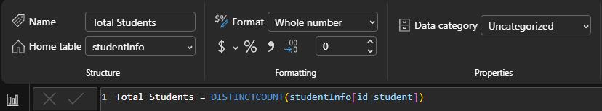

VLE measures

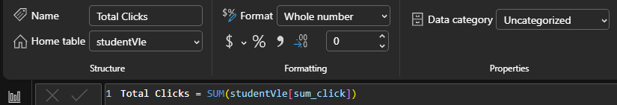

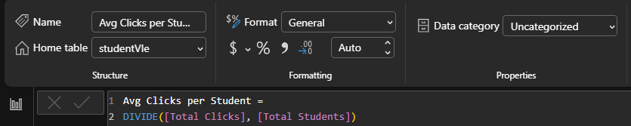

Assessment measures

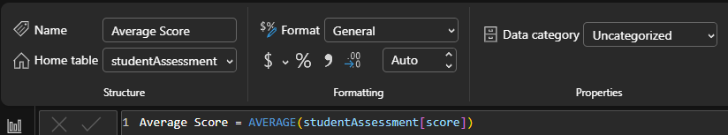
(Assuming pass = score ≥ 40)

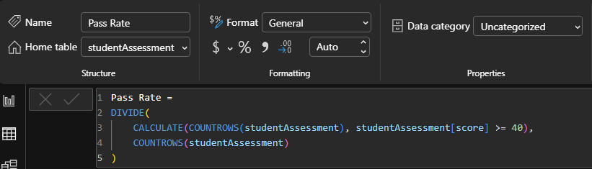

Student Outcomes measures

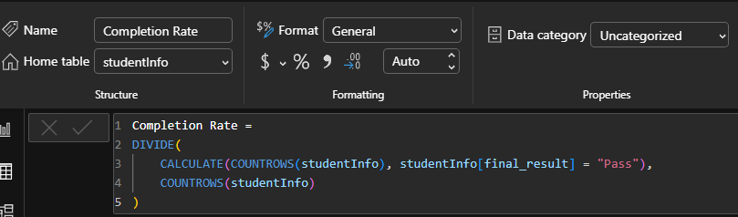

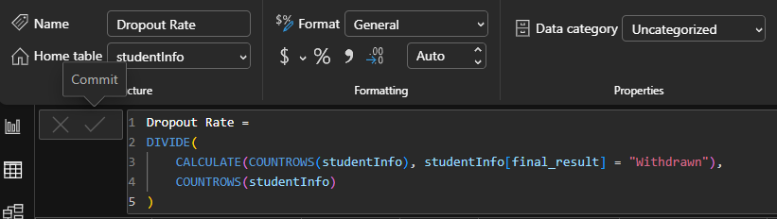

Risk indicator
At-Risk Students
(low engagement + low score)

